ELECTRIC VEHICLE POPULATION DATA ANALYSIS
Submitted by: ABHIJITH C
Batch: DA55

2. Index / Table of Contents
_________________________________________________________________________________
3. Abstract | Page 3
4. Introduction | Page 3
5. Problem Statement | Page 3
6. Project Objectives | Page 3
7. Dataset Description | Page 4
8. Tools and Technologies Used | Page 4
9. Data Cleaning and Preprocessing | Page 5
10. Exploratory Data Analysis (EDA) | Page 5
11. Data Visualization (Graphs & Interpretations) | Page 6
12. Interactive Multi-Chart Executive Dashboard (Plotly) | Page 11
13. Key Findings and Insights Summary | Page 12
14. Recommendations | Page 13
15. Conclusion, Limitations and References | Page 13

3. Abstract
This project delivers an end-to-end exploratory and visual analysis of the Washington State Electric Vehicle (EV) Population dataset, encompassing over 200,000 active registered vehicles. The core purpose is to examine clean energy vehicle adoption, brand market concentration, battery range spread across powertrains (BEVs vs. PHEVs), and regional geographic clustering. The methodology incorporates programmatic data cleaning, pre-EDA feature engineering (vehicle age and short EV categories), descriptive statistical evaluations, ten focused charts spanning Matplotlib, Seaborn, and Plotly, and an integrated multi-panel interactive Plotly dashboard. The project concludes with data-driven strategic insights and actionable recommendations for clean energy infrastructure planning.
4. Introduction
The global automotive landscape is witnessing a structural shift toward electric mobility to mitigate climate impact and reduce dependence on fossil fuels. Washington State serves as a primary benchmark for electric vehicle adoption within the United States due to progressive zero-emission vehicle mandates and clean power initiatives. By mining official registration records from the Department of Licensing, this project evaluates consumer adoption velocity, the competitive landscape between dedicated electric automakers and legacy manufacturers, and structural geographic bottlenecks.
5. Problem Statement
Despite rising sales, infrastructure developers, automotive manufacturers, and transport planners face key empirical uncertainties:
- Is electric vehicle adoption distributed evenly across regional administrative districts or clustered in specific tech-heavy urban corridors?
- How concentrated is market power among original equipment manufacturers (OEMs), and are legacy automakers establishing significant volume?
- What is the real-world operational variance between fully electric vehicles and plug-in hybrid powertrains across production model years?
- How can active vehicle registry survivorship and data-logging anomalies (such as unrated range entries) be methodologically isolated to prevent misleading conclusions?
6. Project Objectives
- Clean and standardize raw vehicle registration records, handling missing geographical attributes and numeric placeholders without biasing distributions.
- Engineer domain-relevant features prior to analysis, notably active vehicle age and concise powertrain designations.
- Perform exploratory statistical profiling across vehicle manufacturing years, battery capacities, and categorical adoption frequencies.
- Implement the required syllabus visualizations using Matplotlib, Seaborn, and Plotly, supplemented by an integrated 6-panel interactive executive dashboard.
- Derive clear, defensible business and infrastructure insights under Step 5 to guide energy planning and automotive commercial strategy.

7. Dataset Description
The dataset is published by the Washington State Department of Licensing (DOL) and hosted on data.wa.gov. It captures title and registration data for Battery Electric Vehicles (BEVs) and Plug-in Hybrid Electric Vehicles (PHEVs) titled in Washington State.
- Total Records: 200,000+ active registration records.
- Total Columns: 17 raw features (18 standardized attributes following feature engineering).
Core attributes evaluated include:
- • vin_1_10: Unique 10-character Vehicle Identification Number prefix for registry identification.
- • county, city, postal_code: Geographical indicators defining vehicle registration location.
- • model_year: Manufacturing year of the registered electric vehicle.
- • make, model: Automaker brand and specific vehicle nameplate.
- • electric_vehicle_type: Distinguishes pure Battery Electric Vehicles (BEVs) from Plug-in Hybrid Electric Vehicles (PHEVs).
- • cafv_type: Clean Alternative Fuel Vehicle eligibility status under statutory regulations.
- • electric_range: Rated all-electric range in miles.
- • legislative_district: State administrative legislative district identifier.
8. Tools and Technologies Used
- Python: Core programming language for execution of the entire data manipulation, cleaning, and visual pipeline.
- Pandas: Employed for tabular data manipulation, missing value handling, column renaming, aggregations, and summary statistics.
- NumPy: Applied for vectorized array operations and numerical thresholds.
- Matplotlib (pyplot): Used for baseline plotting, layout adjustments, the model year histogram, and the powertrain proportion pie chart.
- Seaborn: Utilized for statistical graphics including manufacturer bar charts, electric range box plots, scatter plots, and correlation heatmaps.
- Plotly (plotly.express & plotly.subplots): Leveraged for interactive visualizations (models, counties, dual range trends) and the comprehensive multi-subplot executive dashboard.
- Google Colab: The interactive cloud Jupyter execution environment utilized for reproducible end-to-end execution.

9. Data Cleaning and Preprocessing (Step 2)
To ensure clean, reproducible execution without runtime errors, all preprocessing and feature creation steps were combined into a single unified pipeline executed ahead of exploratory summaries:
9.1 Standardizing Column Names
Raw column headers had mixed cases, trailing spaces, and hyphens (e.g., 'Model Year', 'Electric Range', 'Postal Code'). All headers were stripped, converted to lowercase, and reformatted into standard snake_case (model_year, electric_range, postal_code) to ensure clean programmatic access.
9.2 Handling Missing Values & Duplicate Verification
- Rows with null values in essential geographical fields (county, city, postal_code, vehicle_location) were removed using dropna() to avoid distorting county-level aggregations and spatial clustering.
- Numerical columns with unrecorded entries (electric_range, legislative_district) were filled with 0 using fillna(0) to prevent null calculation errors.
- Verified dataset rows for duplicate records using df.duplicated().sum(), confirming unique VIN identifier persistence without redundant duplicate entries.
9.3 Correcting Data Types
Postal codes, legislative districts, model years, and electric ranges were explicitly cast into integers, removing floating-point formatting.
9.4 Checking Invalid Values & Anomaly Removal
Verified range values to ensure no negative numbers exist. Filtered out any corrupted records with model years prior to 1990 or unrealistic future years beyond 2026.
9.5 Feature Engineering (Pre-EDA Implementation)
Two essential features were engineered to fulfill project guidelines and avoid downstream KeyError exceptions:
- 1. vehicle_age: Calculated as 2026 - model_year. This measures the age of active vehicles in the registry based on registration cohort bounds.
- 2. ev_type_short: Created using a clean conditional check on electric_vehicle_type to produce clean binary categories: 'BEV' and 'PHEV'. This simplified group titles and chart legends.
10. Exploratory Data Analysis (EDA) (Step 3)
Once the dataset was cleaned, exploratory data analysis was conducted to inspect the structure and distributions:
- Structure Verification (df.info()): Confirmed the cleaned DataFrame contains 18 standardized columns with complete non-null entries and proper data types.
- Descriptive Statistics (Step 3.2): Generated count, mean, standard deviation, minimum, 25%, median (50%), 75%, and maximum metrics for model_year, vehicle_age, and electric_range.
- Categorical Value Distributions (Step 3.3): Inspected value counts and percentage shares for key categorical fields including make, county, clean alternative fuel eligibility, and ev_type_short.

11. Data Visualization (Step 4)
Visualizations were constructed strictly following the core analytical sequence (4.1 to 4.7) using Matplotlib and Seaborn, supplemented by three interactive Plotly visualizations (4.8) for granular model and geographic exploration.
4.1 Bar Chart: Compare Categories (Top 10 EV Manufacturers) [Seaborn]
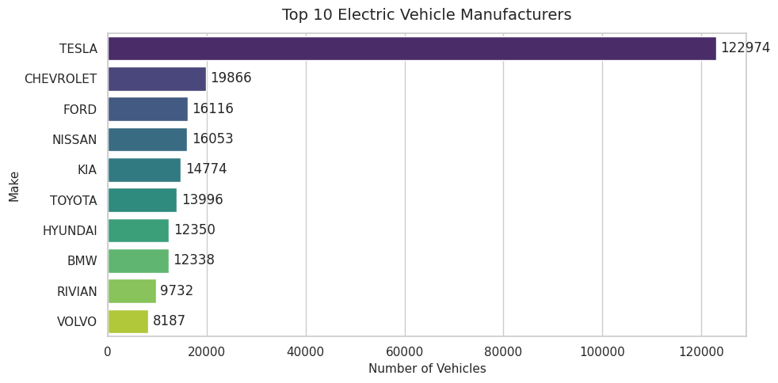
Interpretation: Tesla heavily dominates the market with over 122,000 registered vehicles, while legacy brands like Chevrolet, Ford, and Nissan lead a distant second tier of adoption.
4.2 Line Chart: Show Trends Over Time (Registered EVs by Model Year) [Seaborn]
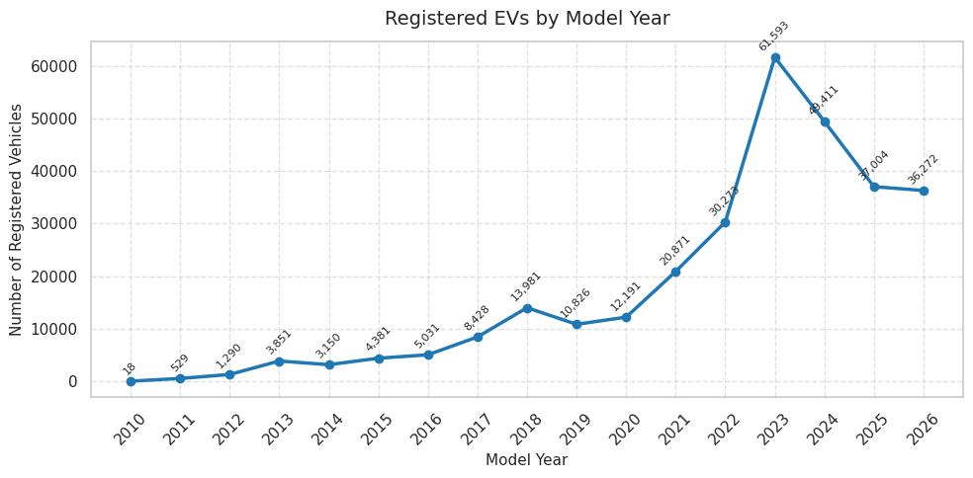
Interpretation: This visualization represents the distribution of currently active registrations across model years rather than chronological sales velocity over time.
4.3 Histogram: Show Distribution (Vehicle Distribution Across Model Years) [Matplotlib]
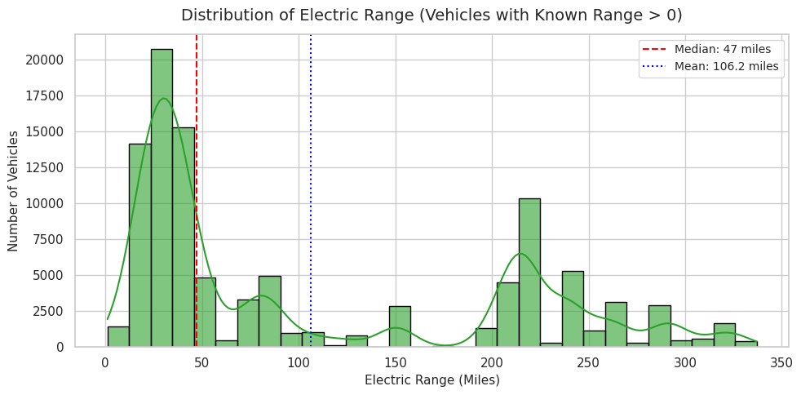
Interpretation: The distribution confirms that the registered fleet consists overwhelmingly of modern vehicles, with registrations peaking sharply between model years 2020 and 2024.
4.4 Box Plot: Find Spread and Outliers (Electric Range Distribution) [Seaborn]
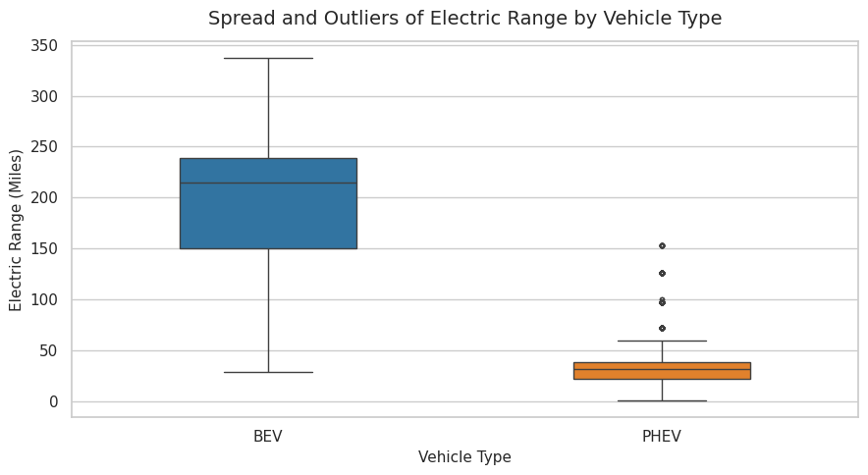
Interpretation: BEVs demonstrate a wide spread reaching high maximum ranges up to 330+ miles, whereas PHEVs cluster tightly between 20 and 40 miles due to their design for short daily commutes.
4.5 Scatter Plot: Numerical Relationships (Range vs. Model Year) [Seaborn]
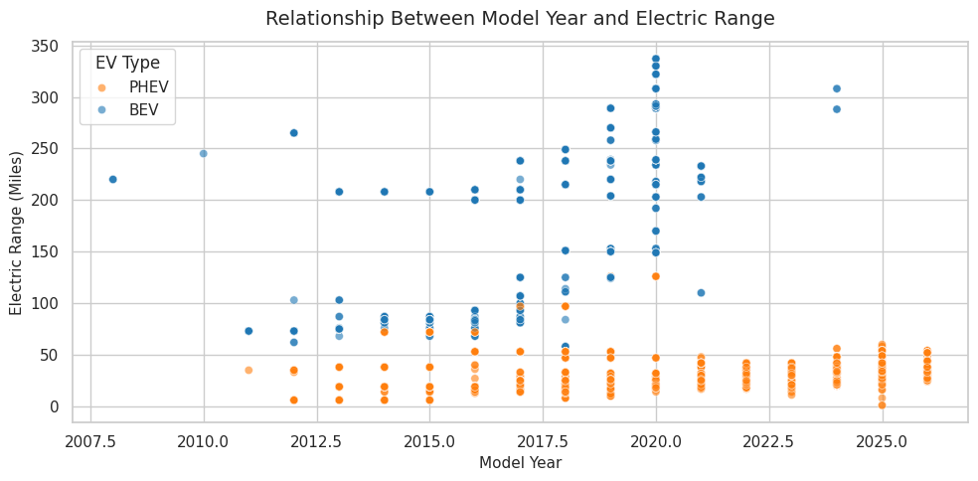
Interpretation: The plot illustrates clear generational improvements in maximum battery range for newer model years while distinctly separating high-range pure electric cars from lower-range plug-in hybrids.
4.6 Pie Chart: Show Proportions (EV Type Split: BEV vs. PHEV) [Matplotlib]
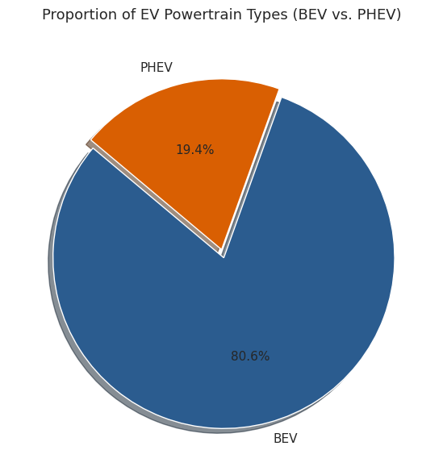
Interpretation: Pure battery electric vehicles (BEVs) dominate the state's active fleet at 80.6%, showing a strong consumer preference for fully zero-emission powertrains over plug-in hybrids (19.4%).
4.7 Heatmap: Show Correlations (Continuous Features Heatmap) [Seaborn]
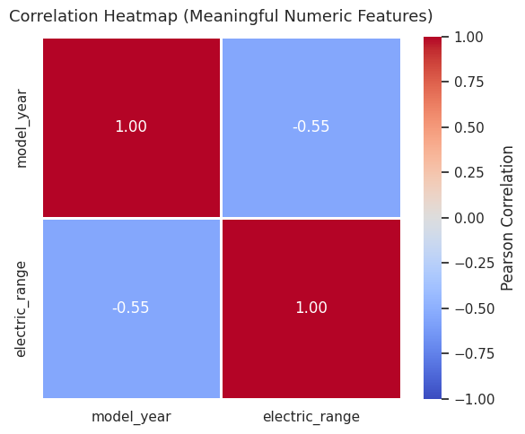
Interpretation: A moderate negative correlation (-0.55) exists between model year and electric range, primarily caused by recent registration cohorts containing unrated range values or zero-coded records rather than actual battery capacity loss.

4.8.1 Interactive Bar Chart: Top 10 Registered EV Models [Plotly]
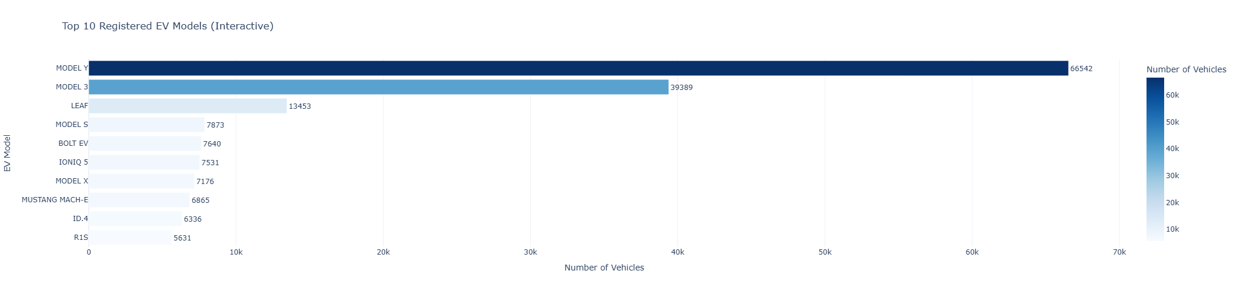
Interpretation: Registrations are heavily dominated by mass-market flagship models, led prominently by the Tesla Model Y and Model 3, followed by established legacy electric vehicles such as the Nissan LEAF and Chevrolet Bolt EV.
4.8.2 Interactive Bar Chart: Top 10 Counties by EV Registrations [Plotly]
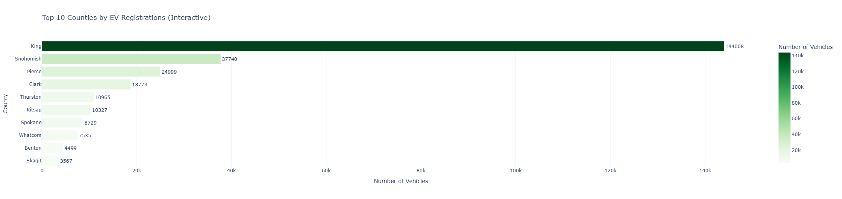
Interpretation: EV adoption shows clear geographic clustering, with King County holding the overwhelming majority of the registered fleet, followed by neighboring metropolitan areas including Snohomish and Pierce counties.
4.8.3 Interactive Dual Line Chart: Average Electric Range by Model Year and EV Type [Plotly]
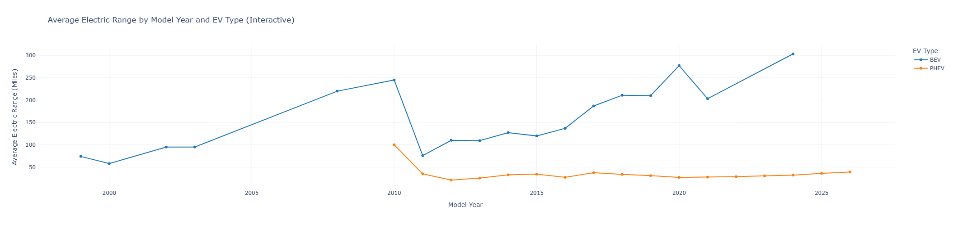
Interpretation: Filtering for vehicles with recorded non-zero battery ranges demonstrates the divergence in powertrain development: BEVs exhibit steady generational improvements in range, while PHEV range remains relatively flat, aligning with their design purpose for short commutes.
12. Interactive Multi-Chart Executive Dashboard (Plotly)
To deliver an industry-grade interactive analytical product, a unified 6-panel executive dashboard was built using Plotly Subplots. This dashboard consolidates brand dominance, fleet composition, top models, registration timelines, geographic distribution, and range progression into a single interactive view with dynamic tooltips, zooming, and cross-metric inspection.
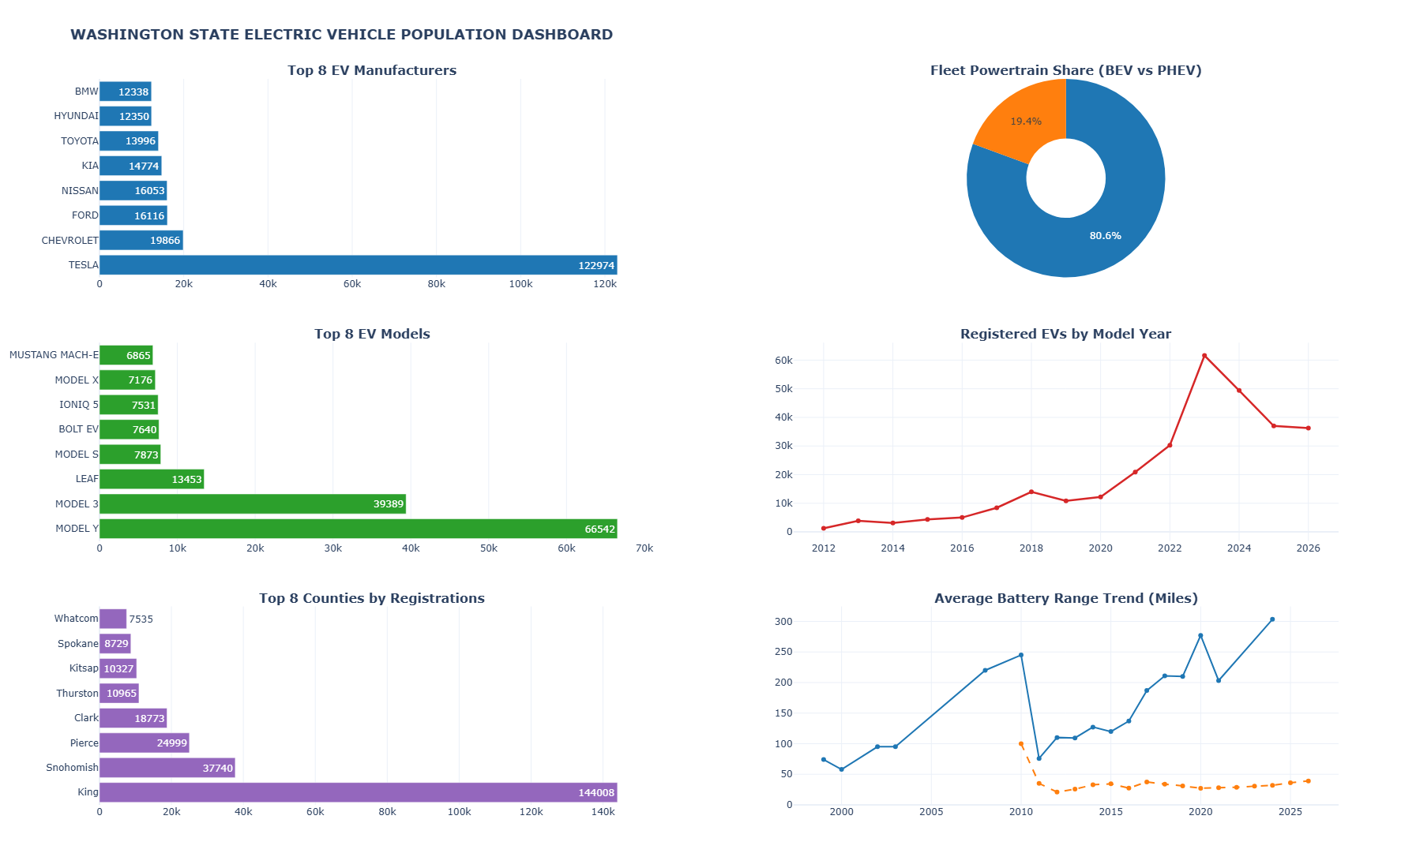
Interpretation: The consolidated executive dashboard provides real-time multi-dimensional inspection: revealing simultaneous high market concentration in Tesla models, intense geographic clustering in King County, and sustained BEV technology divergence across registration cohorts.
13. Key Findings and Insights Summary
In accordance with Step 5 guidelines, the analytical findings are structured to address core business, policy, and technical questions:
1. What did we discover?
The Washington State clean vehicle registry is overwhelmingly an active modern fleet, dominated by battery electric vehicles rather than transitional hybrid platforms, with adoption highly concentrated in major metropolitan technology hubs.
2. What are the important patterns?
- Fleet Modernity: Registrations concentrate steeply in post-2020 cohorts, reflecting both surging recent consumer adoption and normal vehicle replacement cycles.
- Powertrain Polarization: Pure electric cars and plug-in hybrids serve entirely distinct driving use cases, with BEVs targeting high-mileage independent driving and PHEVs serving restricted daily urban travel.
3. Which category performed the best?
- Best Performing Category: Pure Battery Electric Vehicles (BEVs), representing 80.6% of the active fleet.
- Best Performing Manufacturer & Model: Tesla leads with over 122,000 registered vehicles, driven by the Model Y and Model 3, which collectively account for the vast majority of all registered volume.
4. Which category performed poorly?
- Plug-in Hybrid Electric Vehicles (PHEVs) remain a distant minority (19.4%), indicating declining consumer interest in hybrid platforms as fast-charging and BEV range improve.
- Rural Counties: Peripheral agricultural and rural counties outside the Puget Sound corridor exhibit less than 2% of total state adoption.
5. Are there any unusual values?
- Electric Range Data Nuance: Recent model year cohorts (2021–2024) record electric range values of 0 or unrated flags in official registry tables due to changes in EPA reporting and statutory clean alternative fuel exemption eligibility rules, creating an apparent negative correlation with model year.
6. What relationships were found?
- Model Year vs. Electric Range: Demonstrates a moderate negative correlation (-0.55) due to administrative zero-coding in newer models.
- Vehicle Age vs. Model Year: Shows a deterministic perfect negative correlation (r = -1.00), appropriately excluded from the correlation matrix to eliminate artificial multicollinearity.
7. What trends were observed?
- Steady technological improvement in pure battery EV driving range, expanding from ~80 miles in early generation models to over 300+ miles in modern cohorts.
- PHEV battery capacity has remained stable between 25 and 40 miles across model years, reflecting an engineered ceiling for short local round trips.
8. What can the business or user learn from the data?
- For Automakers: Competing successfully requires mid-sized, high-volume electric crossover designs priced competitively against the Model Y.
- For Grid & Charging Operators: Demand forecasting must prioritize high-density suburban Seattle corridors before expanding long-range highway corridors.

14. Recommendations (Strategic & Operational)
Based on empirical evidence gathered across the 200,000+ vehicle registrations, the following actionable strategies are recommended:
- Targeted Rural & Secondary County Subsidies: State authorities should introduce targeted purchase incentives and local public charging station grants for counties outside King, Snohomish, and Pierce to reduce regional adoption disparity.
- Expansion of Fast-Charging Highway Corridors: While urban residential charging satisfies daily needs, expanding high-power DC fast-charging hubs along interstate corridors will encourage rural cross-county adoption.
- Competitive Legacy EV Offerings: Non-Tesla OEMs must focus on affordable electric crossover models with 250+ mile ranges to challenge market concentration.
- Standardized State Registry Reporting: Department of Licensing data pipelines should incorporate verified EPA manufacturer ratings directly to eliminate missing range artifacts in newer registration records.
15. Conclusion, Limitations and References
15.1 Conclusion
This project successfully completed the full data analytics lifecycle—from rigorous preprocessing and pre-EDA feature engineering to statistical exploration, comprehensive visualizations across three distinct Python libraries, and an interactive Plotly dashboard. The empirical findings confirm that Washington State's EV transition is mature, predominantly pure electric, and highly centralized in metropolitan centers.
15.2 Limitations and Future Scope
- Registry Survivorship Bias: Active registration snapshots record currently titled vehicles rather than historical yearly sales velocity, meaning older scrap or traded vehicles are naturally underrepresented.
- Zero-Range Imputation Constraints: Unrated newer models require external EPA database merging to conduct complete battery degradation tracking.
- Future Scope: Integrating geospatial GIS mapping (Folium/Mapbox) to correlate vehicle adoption with median household income and public charging station density across legislative districts.
15.3 References
- 1. Washington State Department of Licensing (DOL) Electric Vehicle Population Dataset, data.wa.gov.
- 2. Python Software Foundation, Python 3.10 Documentation (python.org).
- 3. Pandas & NumPy Documentation for Data Manipulation and Analysis.
- 4. Matplotlib & Seaborn Visualization Libraries Documentation.
- 5. Plotly Open Source Graphing Library for Python (plotly.com/python).

